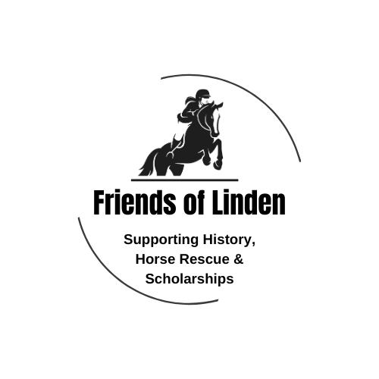

2025 Linden Hunter Show Series & Dressage Series Sponsorship
We need your support to make our show series, and the end of the year banquet a success. The riders work hard to prepare for the series & we want to celebrate their achievements.
Please select your sponsorship level:
- $100 one Dressage Show ribbons & Champion & Reserve Plaques.
- $200–Supports one HUNTER Division in one show.
- $250–Year End Division (supports two trophies, & six large rosettes).
- $___________ (choose your donation amount)
- PURCHASE A PERPENTUAL AWARD. ESTABLISH NAME & CRITERIA FOR THE AWARD.
- Item Donation-We are looking for items for our silent auction at the banquet. What is the item you are wiling to donate: __________________________________ Value: $_____________
All sponsorship levels will have their name displayed in every Series Program and the photo show during the banquet. ---------------------------------------------------------------------------------------------------------
Payment Details
Please send this form along with your ad/message to: lindenfarm2000@gmail.com
Make checks payable to: Friends of Linden – La Plata or we will invoice you.
VENMO or ZELLE: lindenfarm2000@gmail.com 9220 to confirm.
PayPal: lindenfarm2000@gmail.com

Sponsor Name: ________________________________________________________________

Amount Paid: $__________________________ Ad/Message enclosed? _____ Yes _____ No

