Friends of Linden

Judges:
JUDY STROHMAIER
Showmanship: KAREN ALTIERI
Trail: ERIN ALTIERI

Show Managers: Pat Tetrault & Karen Altieri

Announcers: Erin Altieri
Points & Scoring: Angela Deal & Amanda Miller
Ribbons: Charlee Martin
Stewards: Jennifer Walker
Ring Crew: Bryan Deal & Matt Haskin
Information & Ring Control: Val Nocciolo

Food: FARM.FORK.SOUL
Professional Photographer: Bobby Barron of BobbyBarronPhotography.com

Ride Into History

Friends of Linden

PRESENTS IT’S

FIRST SHOW
2025 Hunter Series

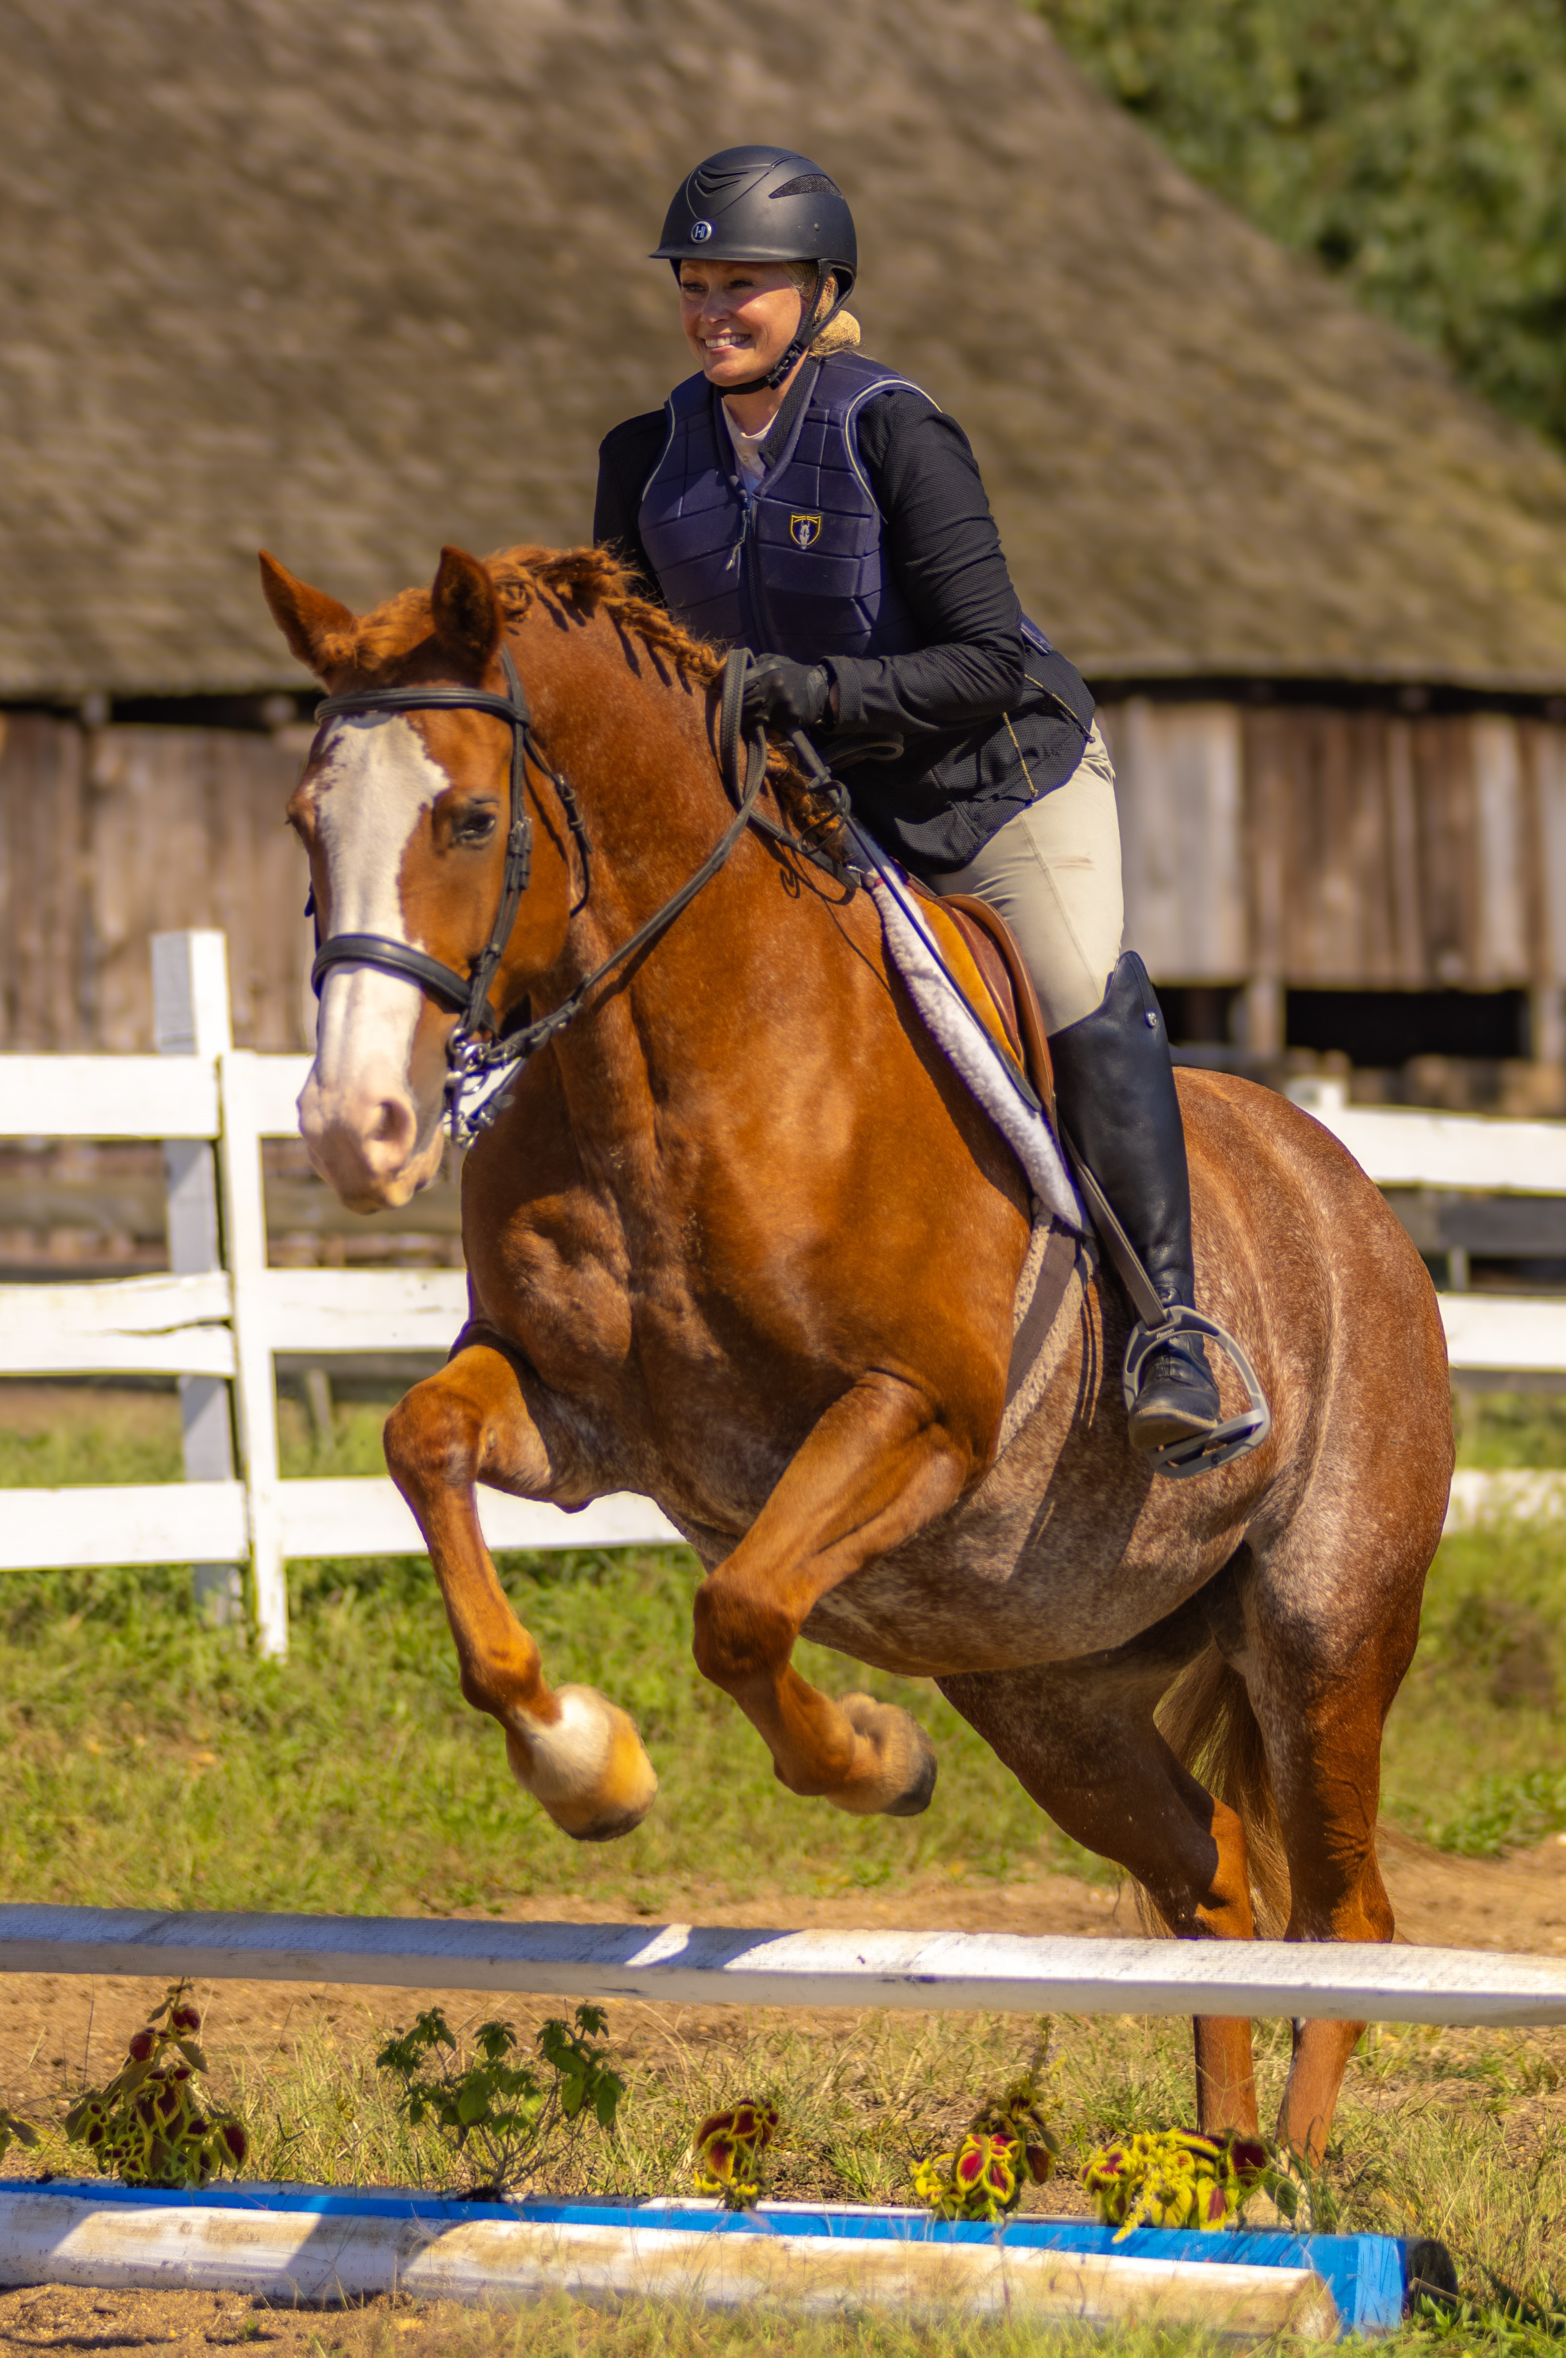

Saturday,

MAY 17, 2025
9:00 a.m.

Ride Into History

MODEL DIVISION (The Altieri Family) Class 1. Model Ponies Class 2. Model Mare Class 3. Model Gelding
LEADLINE CLASS
Class 4. Pony Pleasure
Class 5. Pony Mini-Trail
WALK DIVISION Class 6. Walk Equitation Class 7. Walk Pleasure. Class 8. Walk Over Poles Class 9. Walk-Trot Equitation (Brief Trot)
YOUTH PERFORMANCE
Class 10 – Youth Pleasure W/T Class 11 – Youth Disciplined Rail W/T
YOUTH EQUITATION
Class 12 – Youth Equitation W/T Class 13 – Youth Equitation O/F 12’ TROT
JUNIOR PERFORMANCE WTC (L.K. Deal Electric)
Class 14 – Junior Pleasure Class 15 – Junior Disciplined Rail
JUNIOR EQUITATION WTC
Class 16 - Junior Equitation Class 17 - Junior Equitation O/F 18”
SENIOR PERFORMANCE WTC (L.K.Deal Electric)
Class 18 - Senior Pleasure Class 19 - Senior Hunter under Saddle
SENIOR EQUITATION WTC
Class 20 – Senior Equitation Class 21 – Senior Equitation O/F 18”

NOVICE HORSE PERFORMANCE
Class 22 – Novice Horse Pleasure W/T Class 23 – Novice Horse Disciplined Rail W/T
NOVICE RIDER EQUITATION W/T
Class 24 – Novice Rider Equitation Class 25 – Novice Rider Equitation O/F 12’
ENGLISH FLAT PERFORMANCE W/T(The Dullahan Family)
Class 26 – English Pleasure W/T Class 27 – Hunter Under Saddle W/T
ENGLISH FLAT EQUITATION W/T
Class 28 – English Equitation Class 29 – Command & Out
TRAIL DIVISION (Hopkins Hollow)
Class 30 – Youth Trail Class 31 – Junior Trail Class 32– Senior Trail
SHOWMANSHIP DIVISION
Class 33 – Youth Showmanship 7-12 Class 34 – Junior Showmanship 13-18 Class 35 – Showmanship Senior 18 +
LOW HUNTER OPEN
Class 36Low Hunters 2’ Class 37 Low Hunters 2’
WORKING HUNTER OPEN
Class 38 Working Hunter 2’3” Class 39.Working Hunter 2’3”
Class 40.Working Hunter 2’6”

Names in Red are sponsors for Division Ribbons & Awards.

